OSI Model
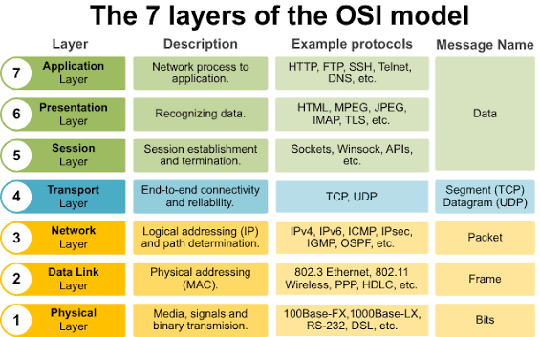

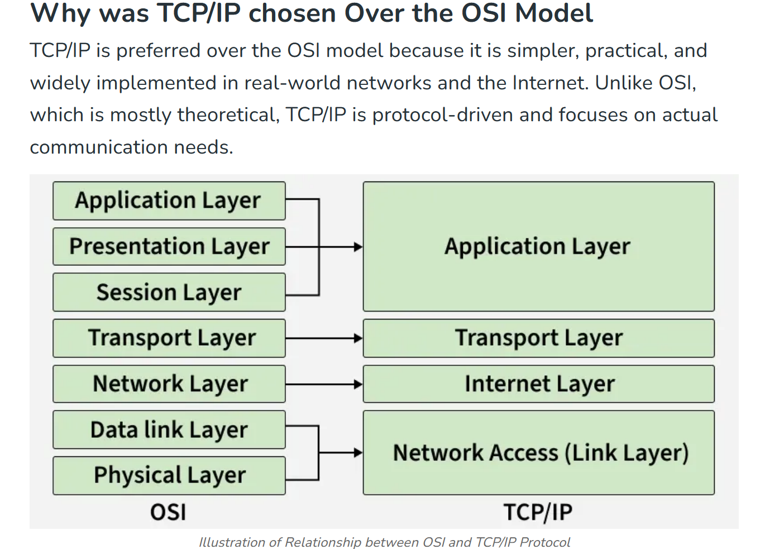

Wireshark Capture: 6+ Protocols
TCP:
In this picture we can see how to tcp protocol works.
TCP (Transmition Control Protocol)is a reliable protocol it makes sure that the data is sent without any corruption.
So it initiates a 3-way Handshake.
- To initiate the connection we send a SYN request to the server.
- Then the server acknowledges and reply with a SYN request + ACK
- At last we send the ACK packet and a reliable connection is build
DNS:
DNS (Domain Naming System) protocol translates the domain name to the ip and connects us to the ip.
In this we can check that we sent a standard query for www.googleadservices.com
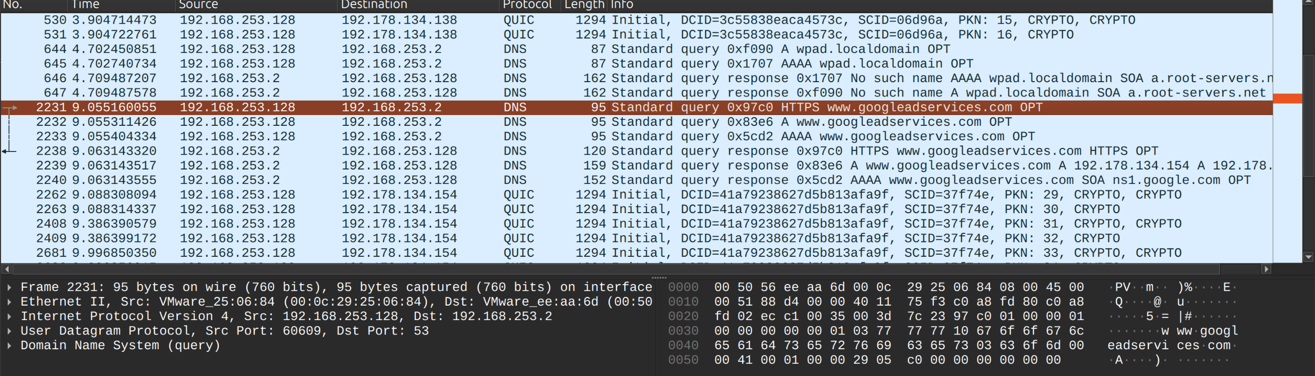
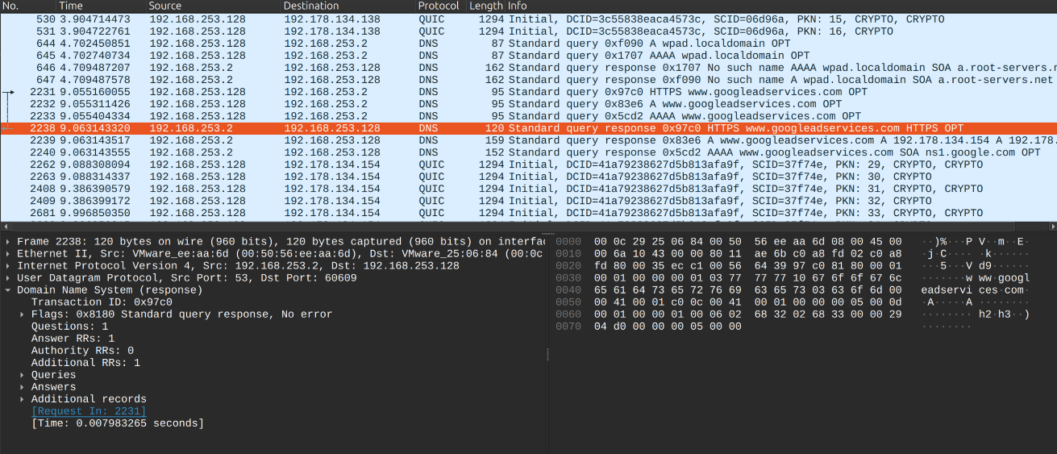
In the next highlighted packet we got the response to our query which resolved without any errors.

HTTP:
http://neverssl.com
I went to a http website and first it creates a get request from the server.
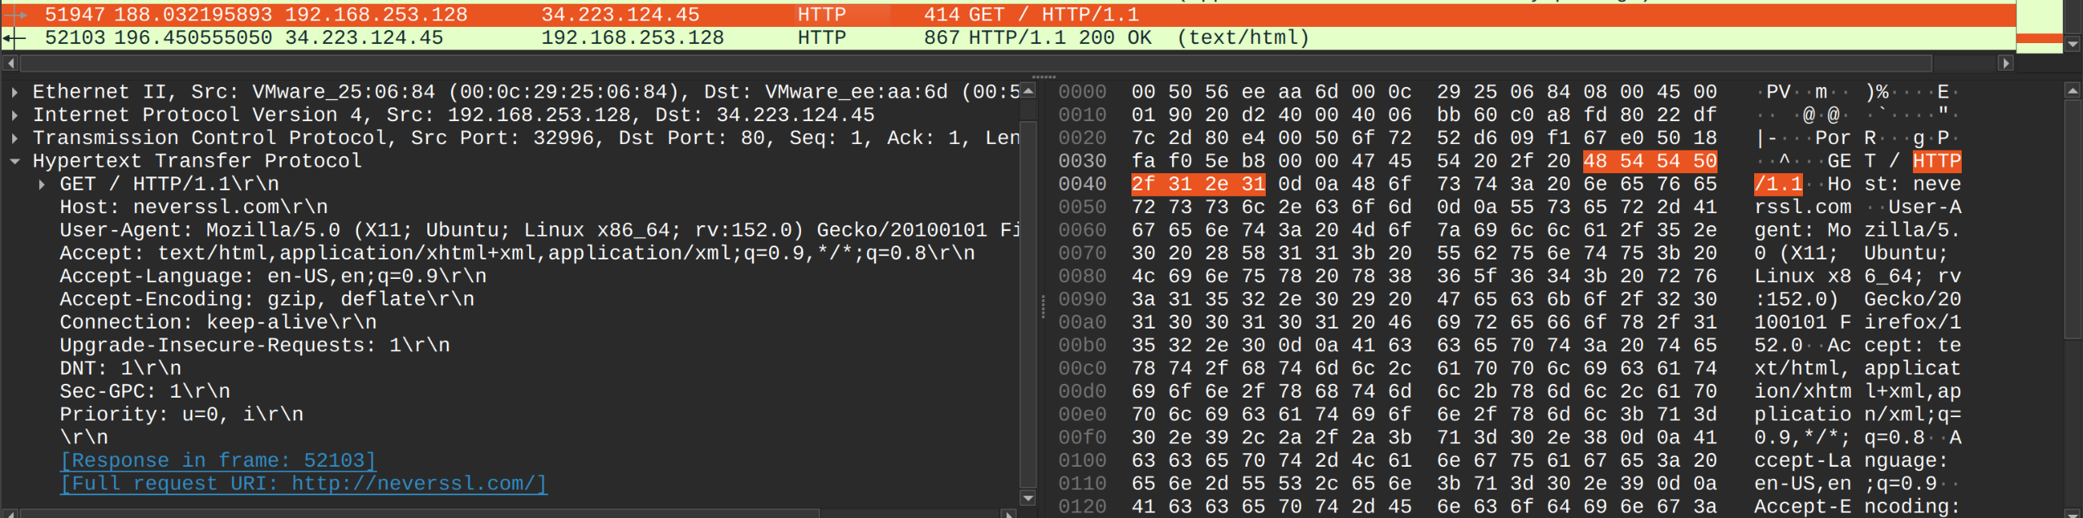
The server reply to the get request and as its only http we can see the plaintext.
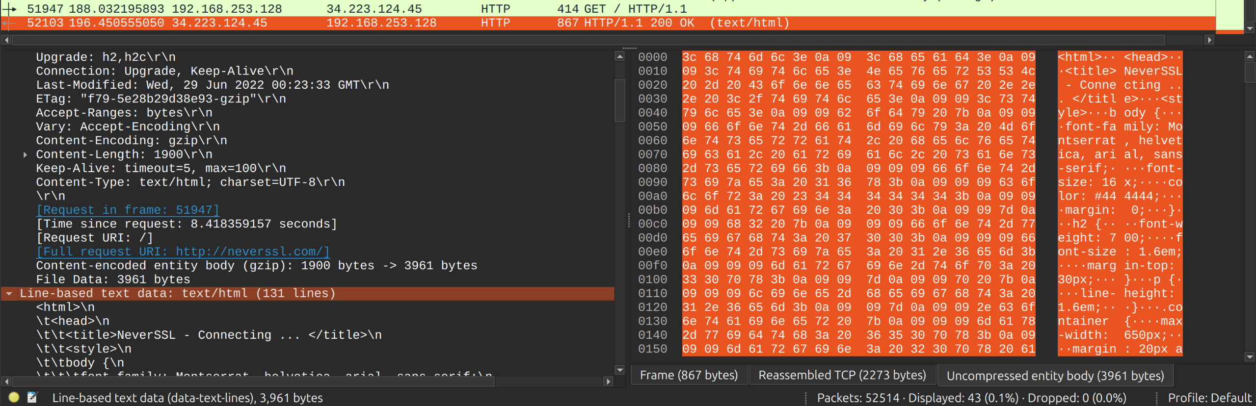

ICMP:
ICMP (Internet Control Message Protocol) is a protocol to check the connection we use ping to the destination in this case google.com and we can the all 4 requests are ok.
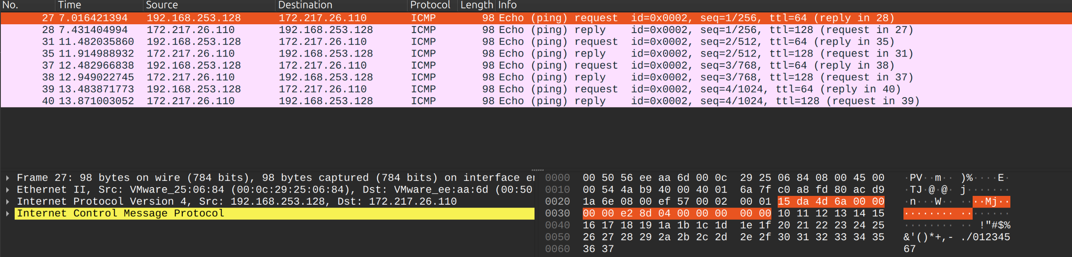

TLSv1.2:
TLS (Transport Layer Protocol) It represents the encrypted https traffic.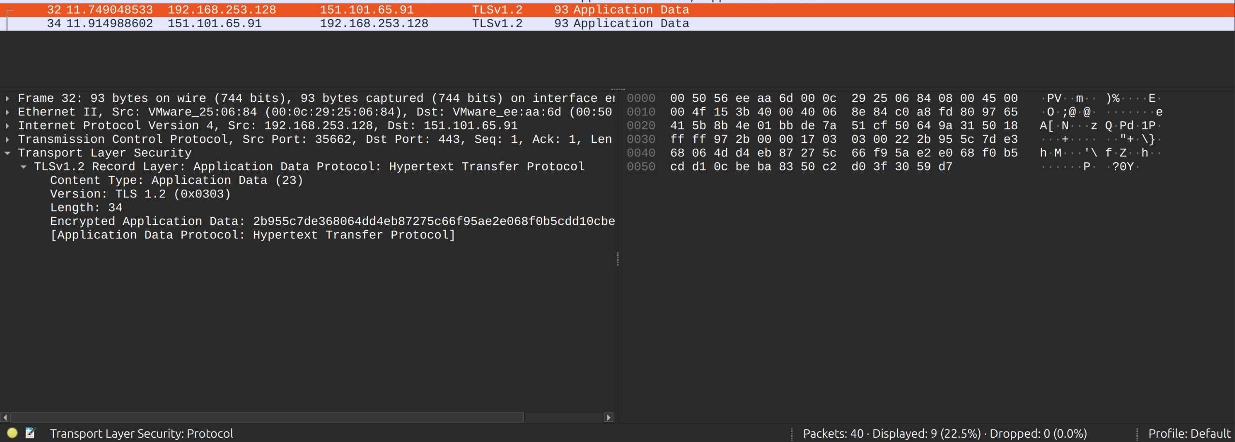

DHCP:
sudo dhclient -r (it releses the current ip which is equivalent to windows ipconfig /release)
sudo dhclient (it is the ipconfig /renew which requests a new ip)
